Lab 01

Name:Muhammad Shahzaib Waseem

Class: BSCS-6B

Registration Number: 187330

# JDK & JRE

1

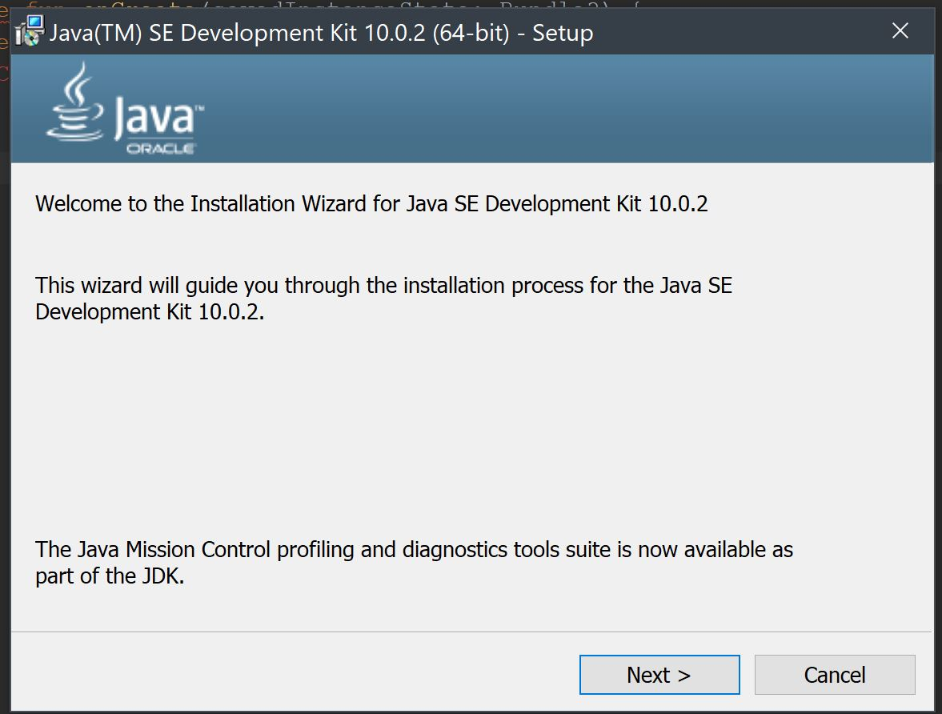

2

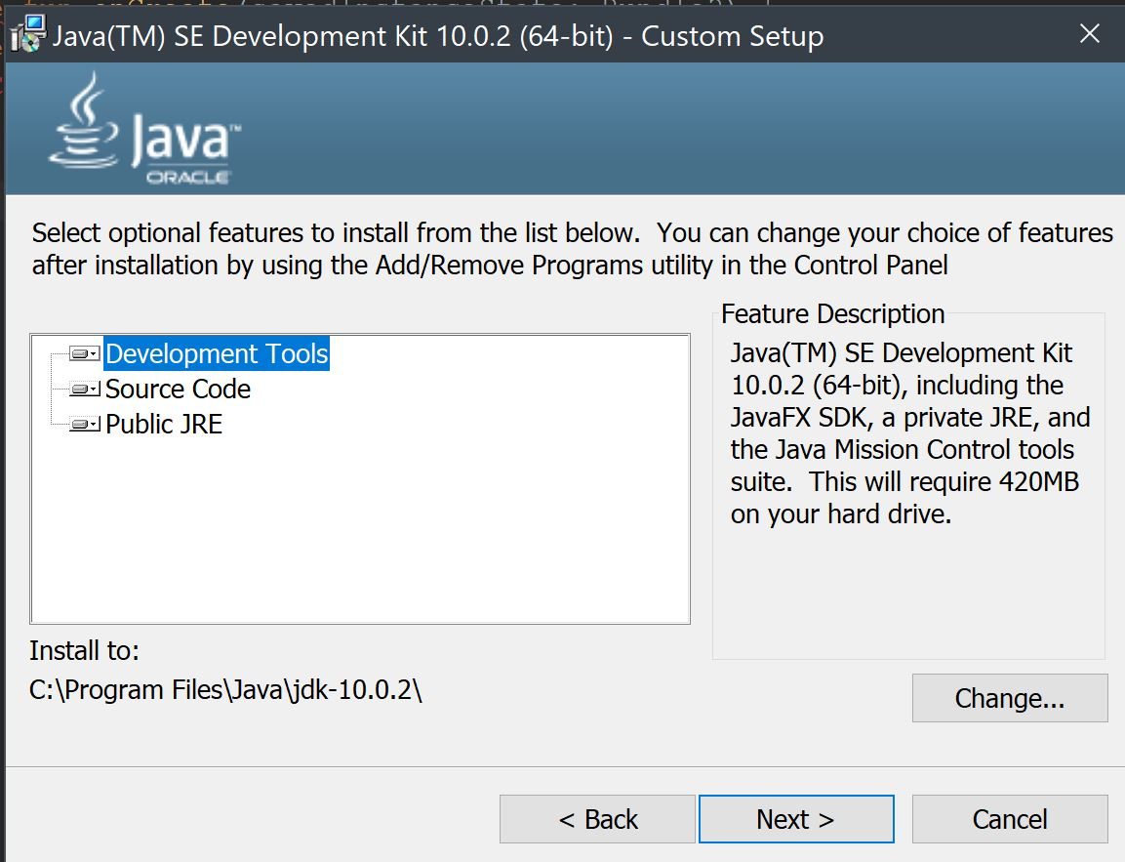

3

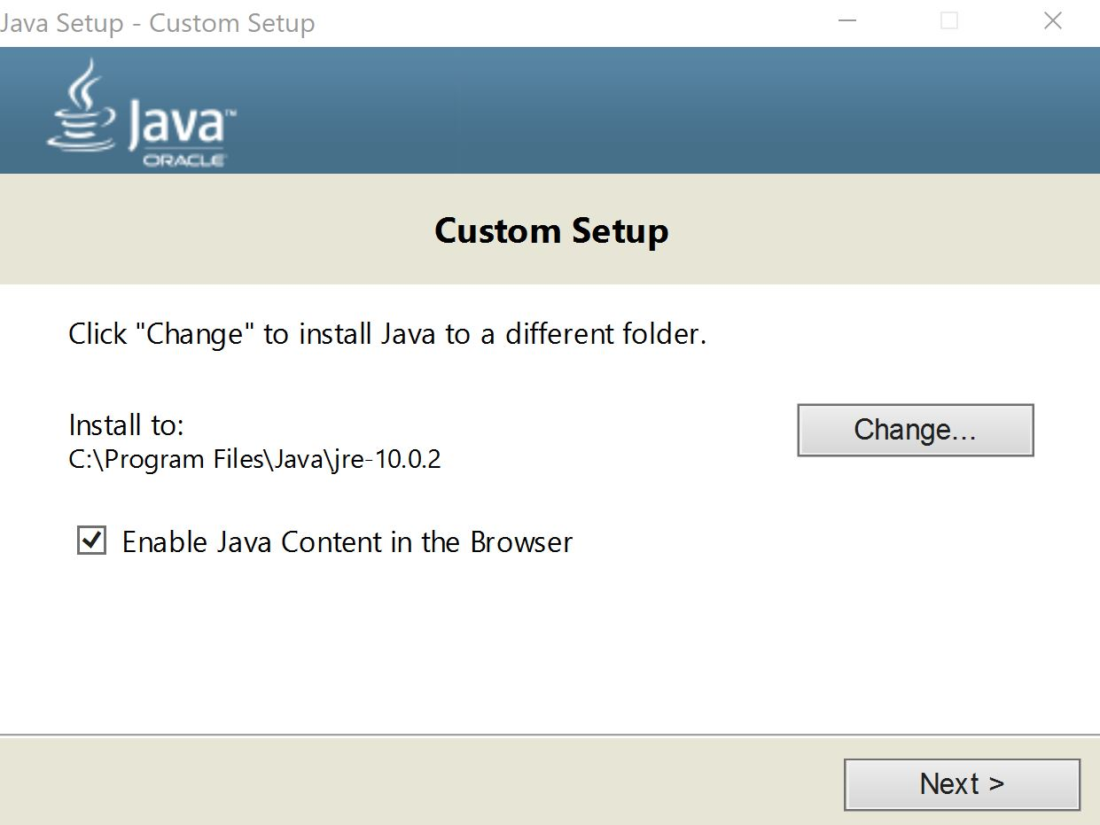

4

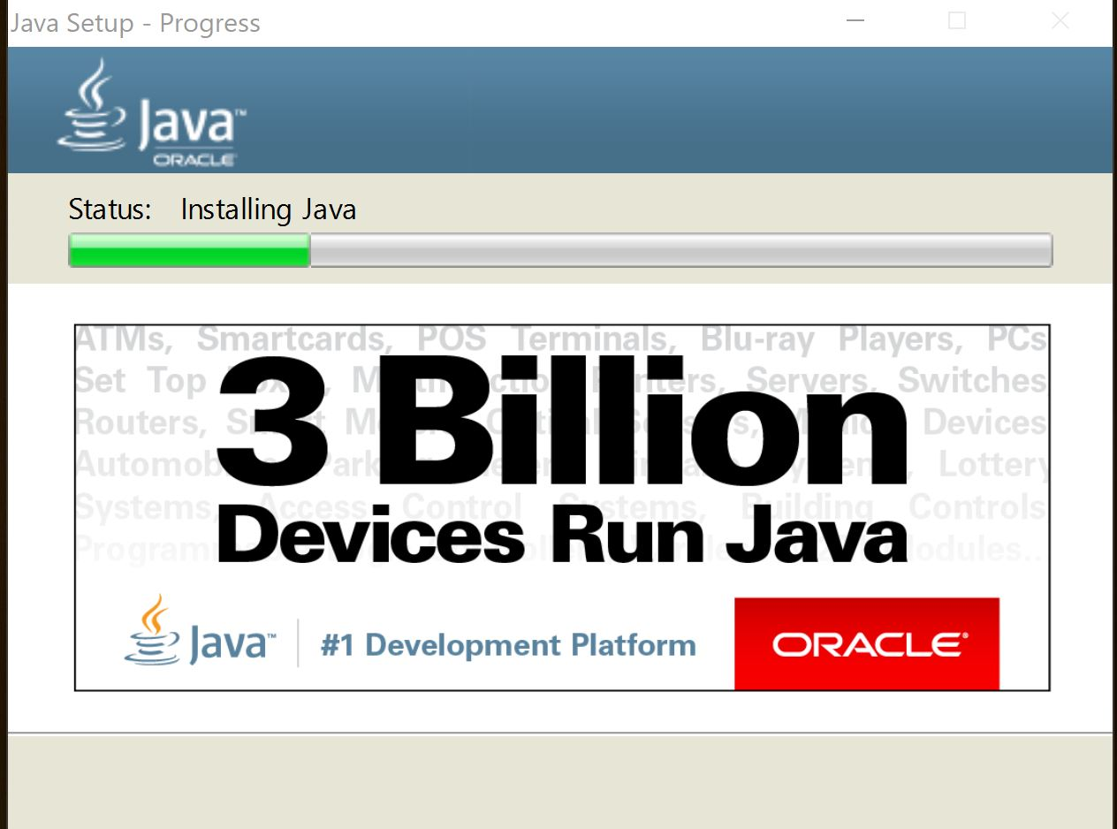

6. Environmental Variables

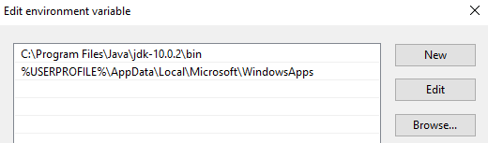

# 

# Eclipse

1. First Page

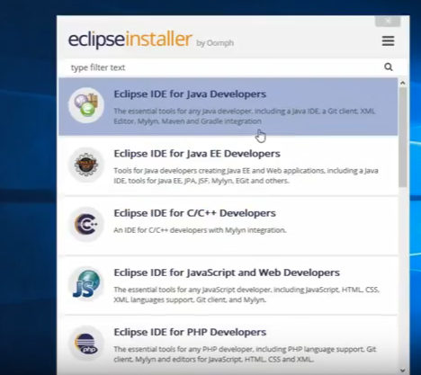

2. Starting Maven

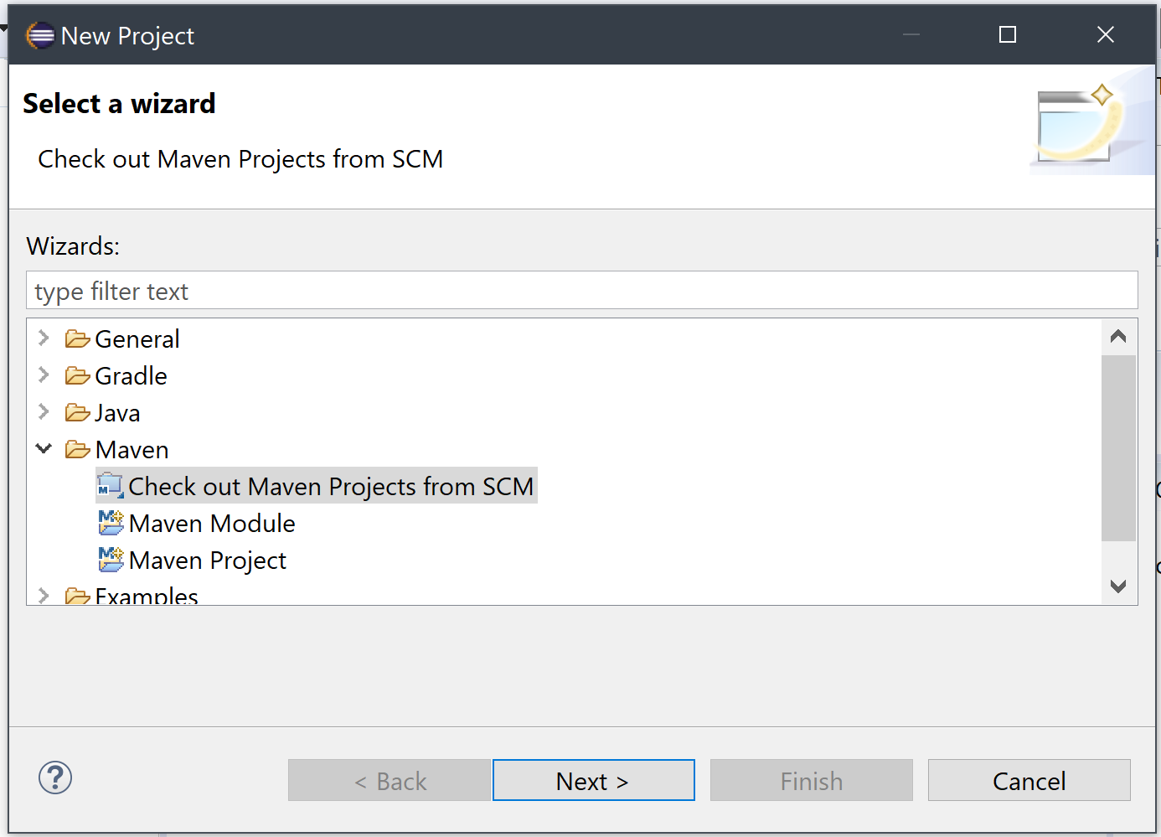

3. Setting up Maven

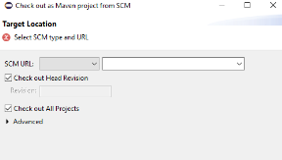

4

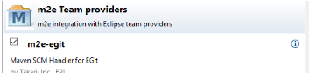

5. Giving the GitHub Repo Link (http://github.com/ShahzaibWaseem/Lab-AP.git)

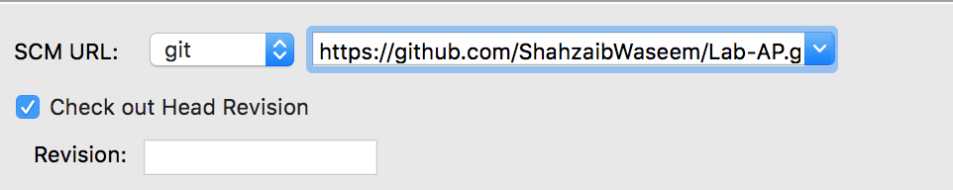

# 

# Android Studio & Kotlin

1. Android Studio Main Page

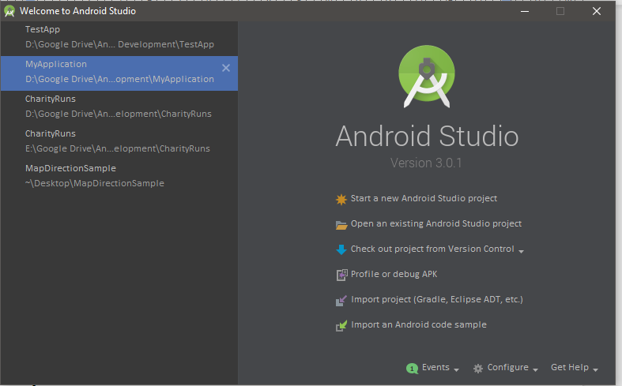

2. Kotlin Update

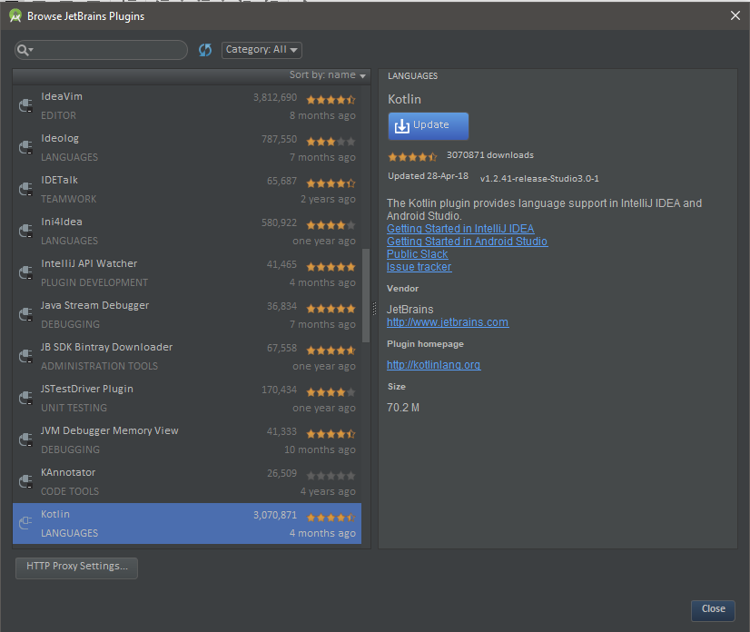

3.Gradle Building

# 

4. Project MainActivity Code

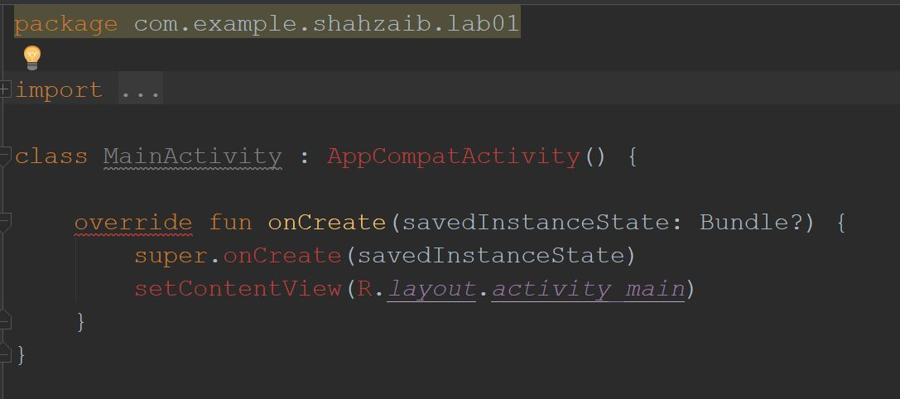

# 

# Visual Studio

1. Installer Installed

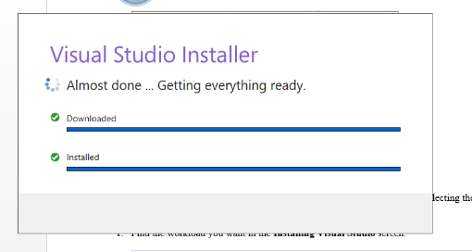

2. Packages

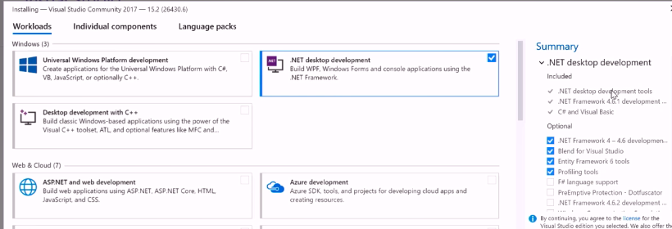

3. Main Page

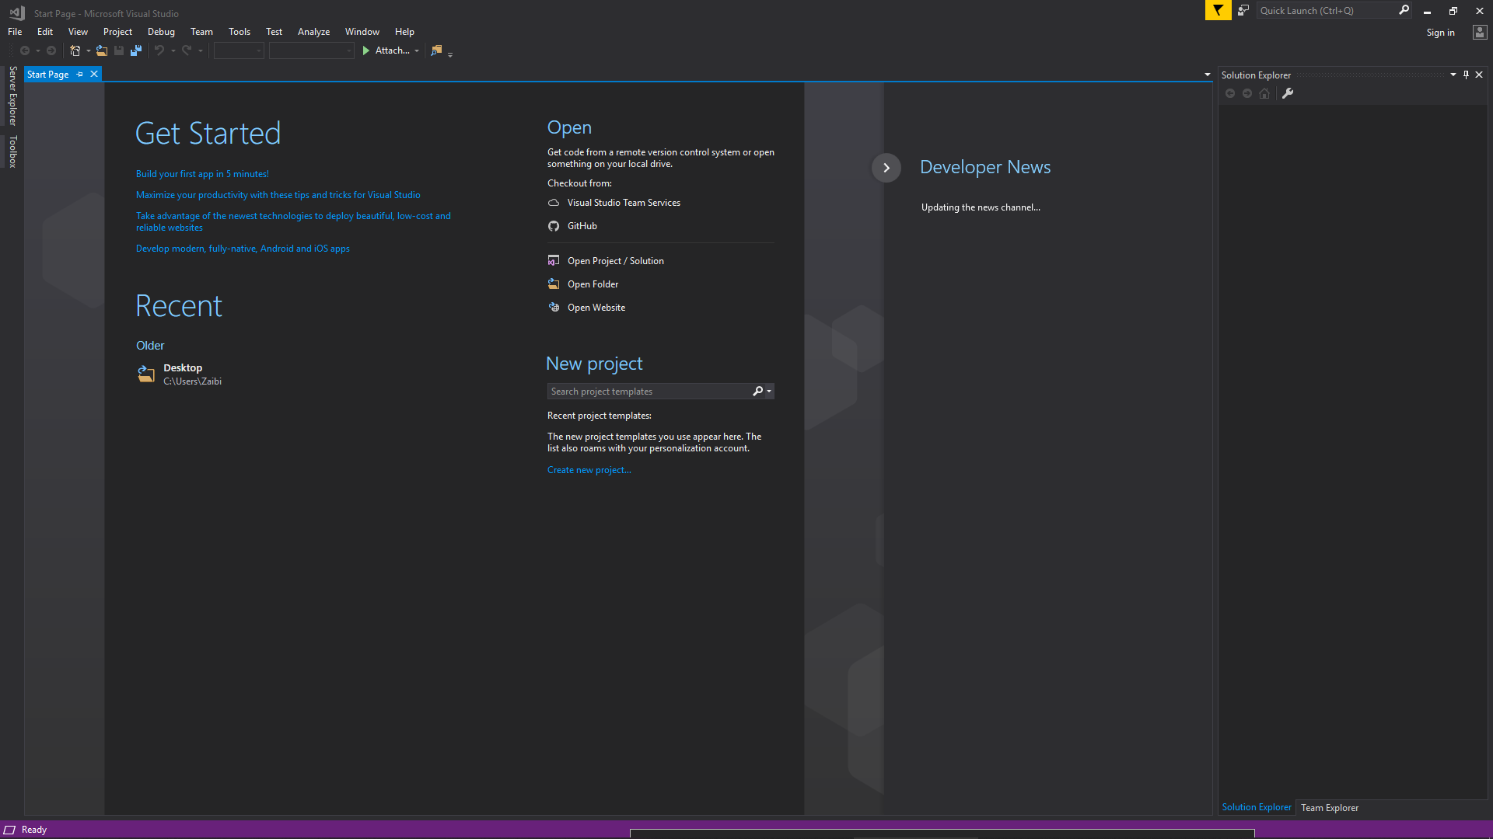

# Python

1. Installing Python

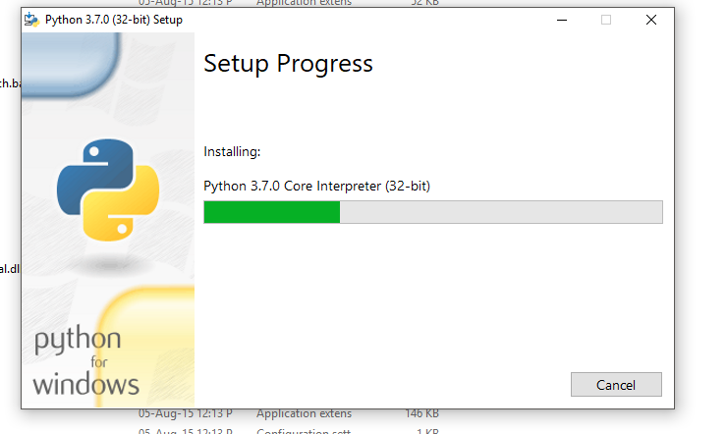

2. Finished Installing

